## **Azure Synapse SQL Pool**

## **Create a Synapse workspace in the Azure portal**

1. In the search results, under Services, select Azure Synapse Analytics.
2. Select Create to create a workspace.

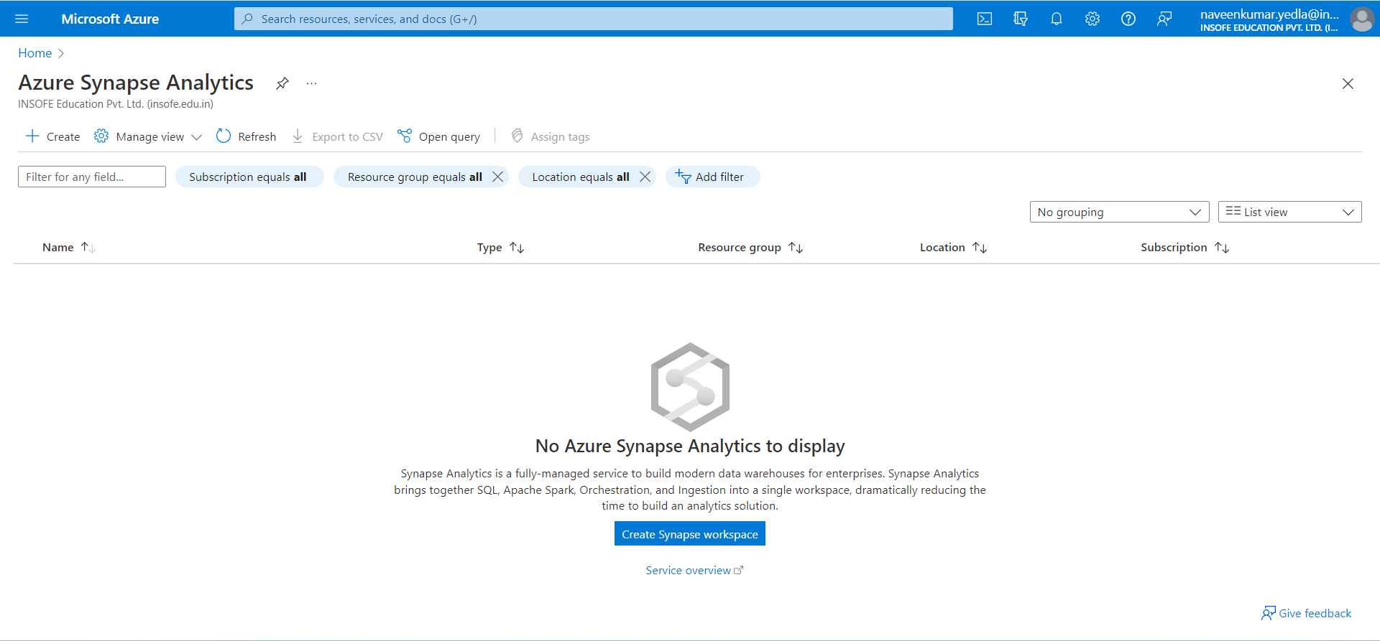

1. In Basic tab enter the following details
2. Subscription: Pay- As-You-Go
3. Resource group: Select resource group if exists otherwise create a new one.
4. Managed group name: Enter a name
5. Workspace name: Enter a name
6. Region: Select the available region (East US)

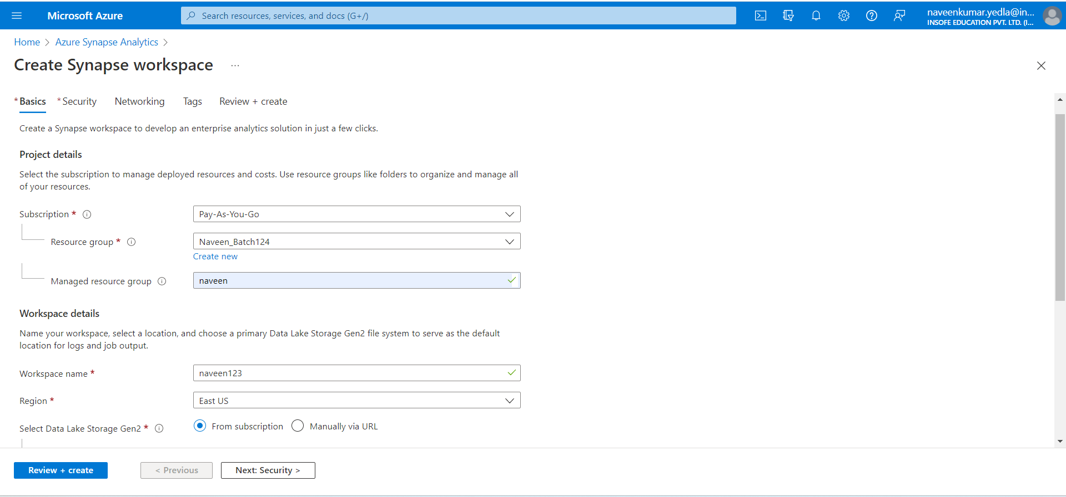

1. Create a new storage account under account name click on create new.

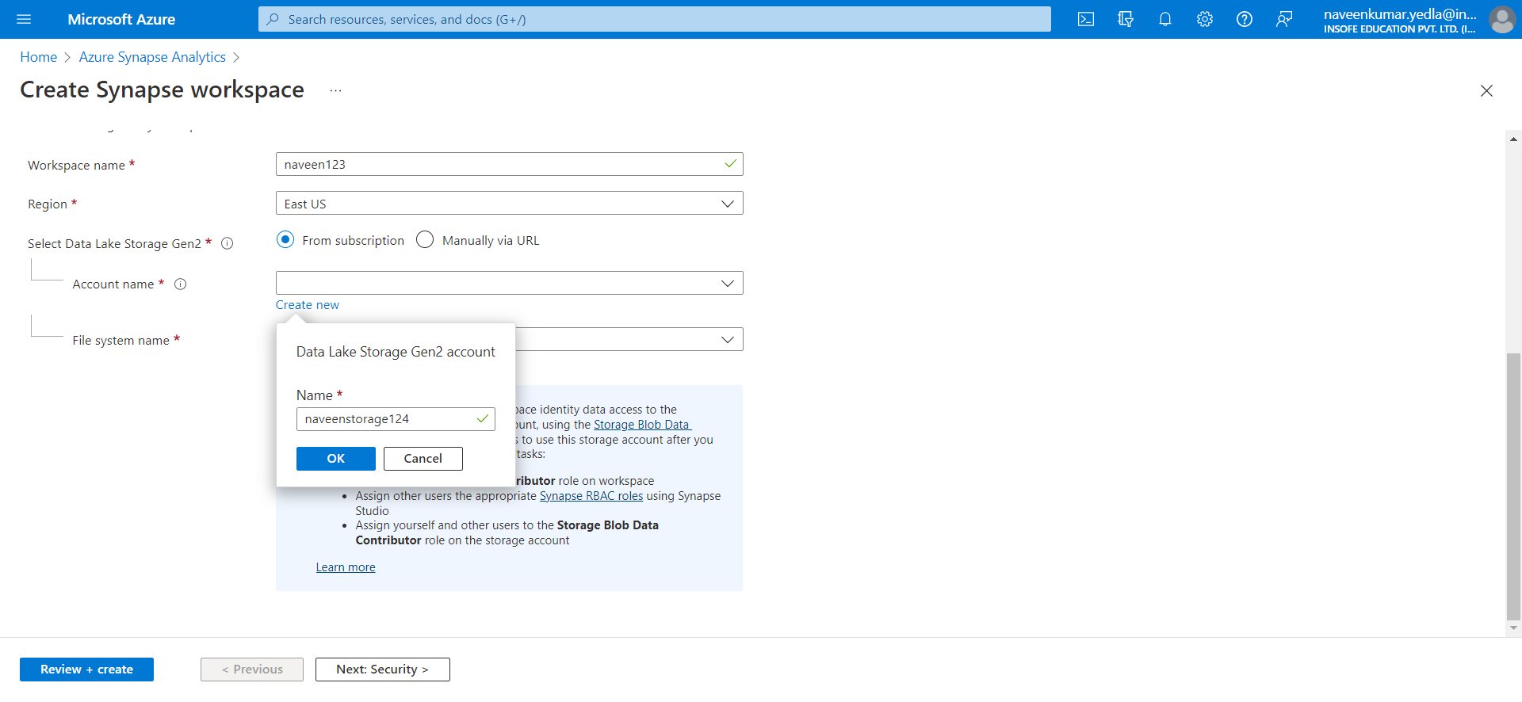

1. Under File system name click on create new.

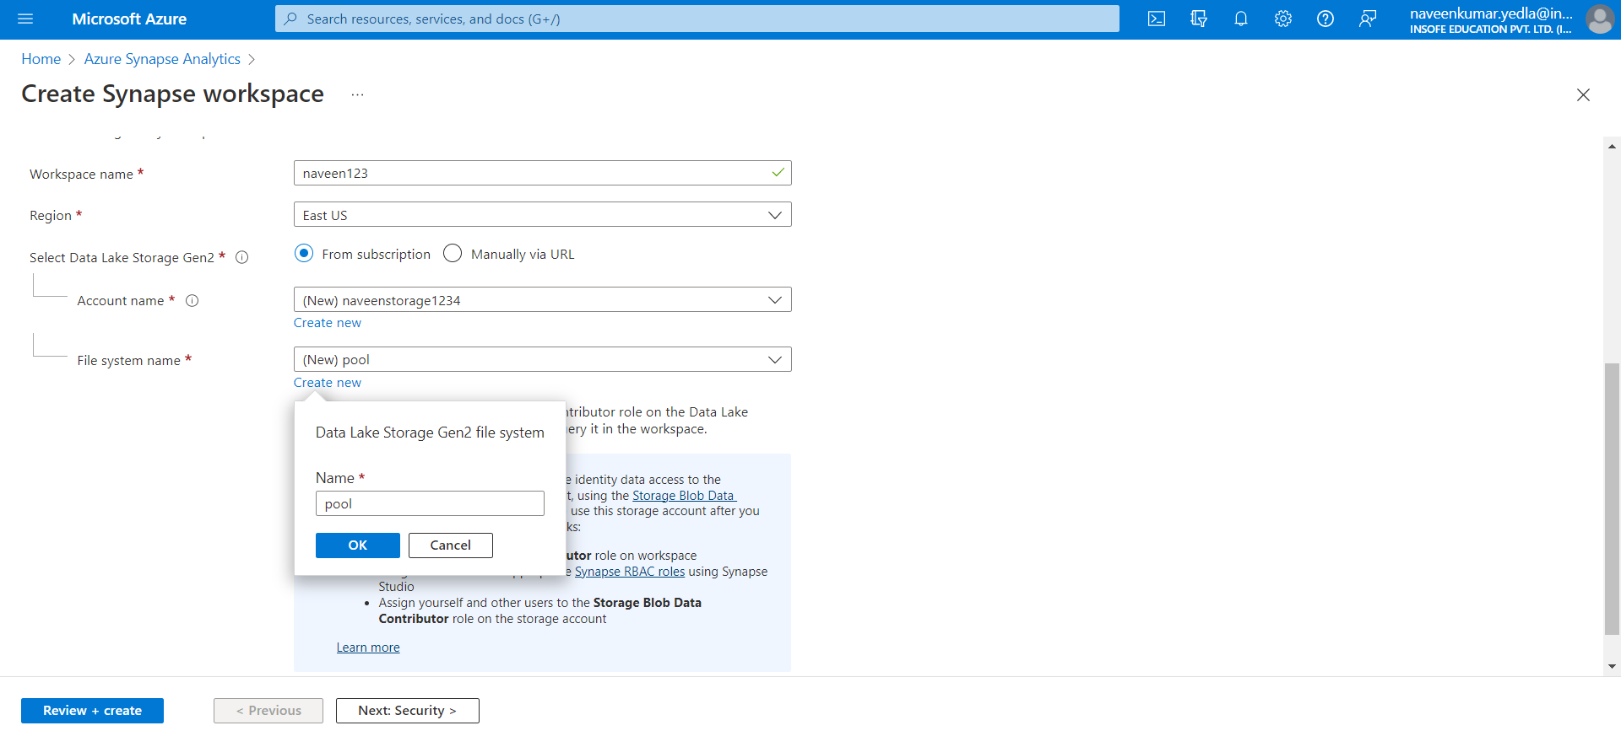

1. Leave remaining options as default. Click on Review + Create.
2. After Validation Succeeded. Click on create.

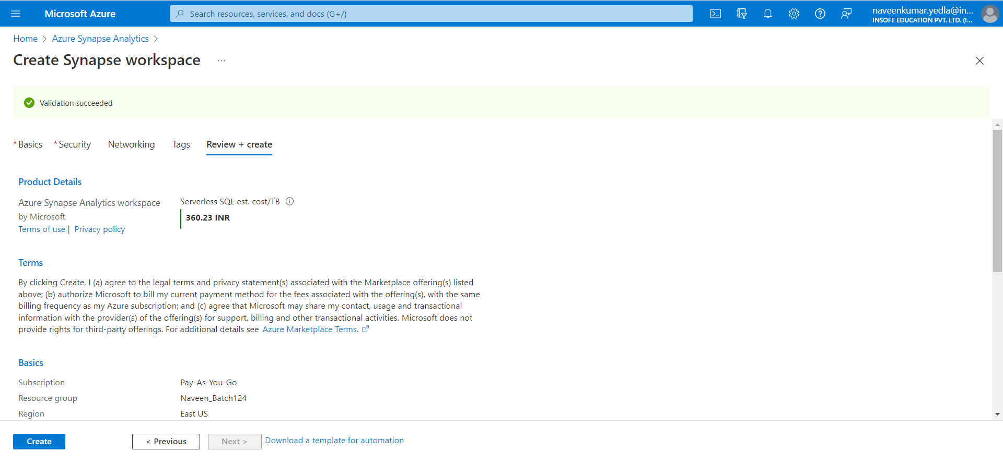

1. It will take few minutes to deploy.

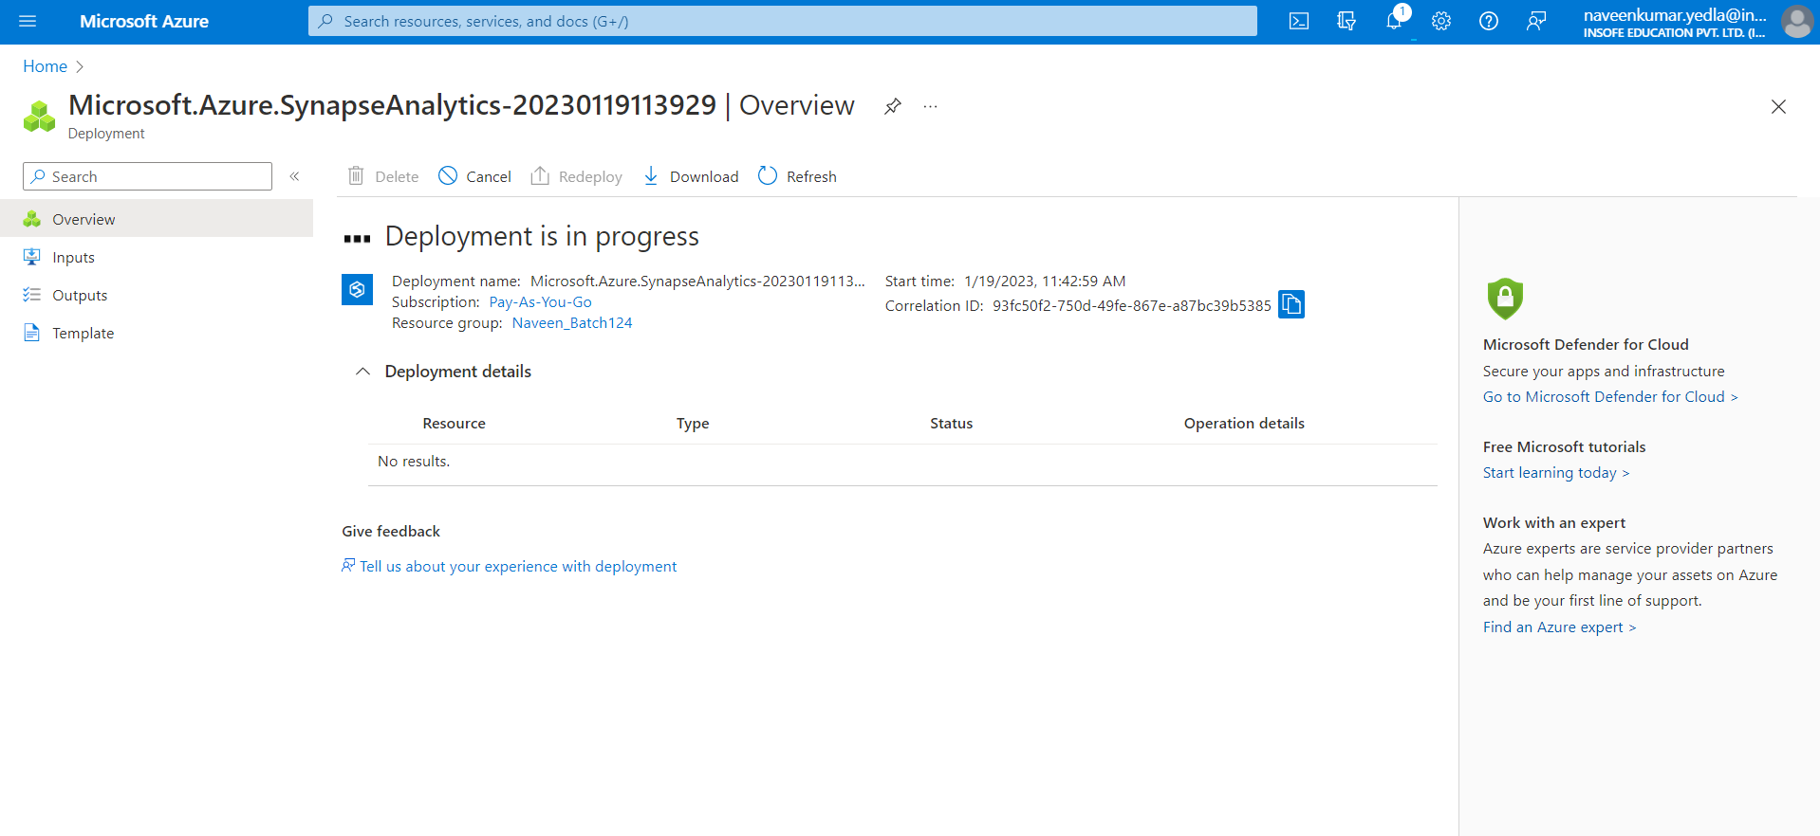

1. After Deployment done Click on go to resource.
2. Click on create.

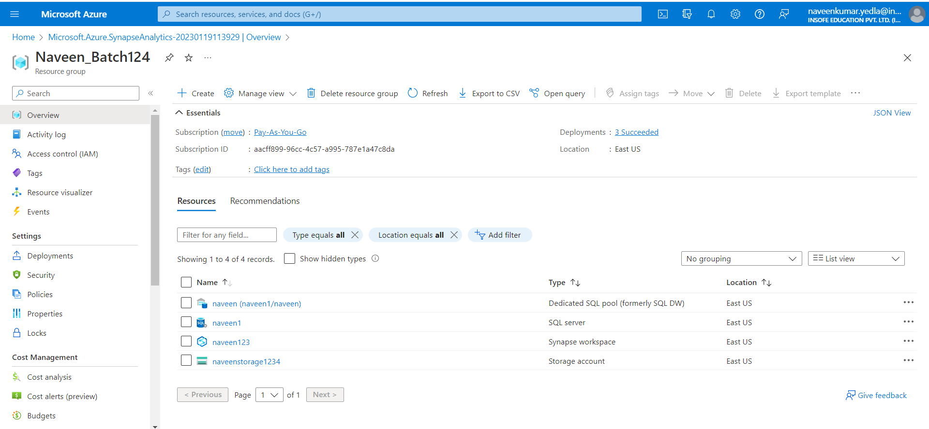

1. Search SQL pool and select Dedicated SQL pool (formerly SQL DW)
2. Click on create.

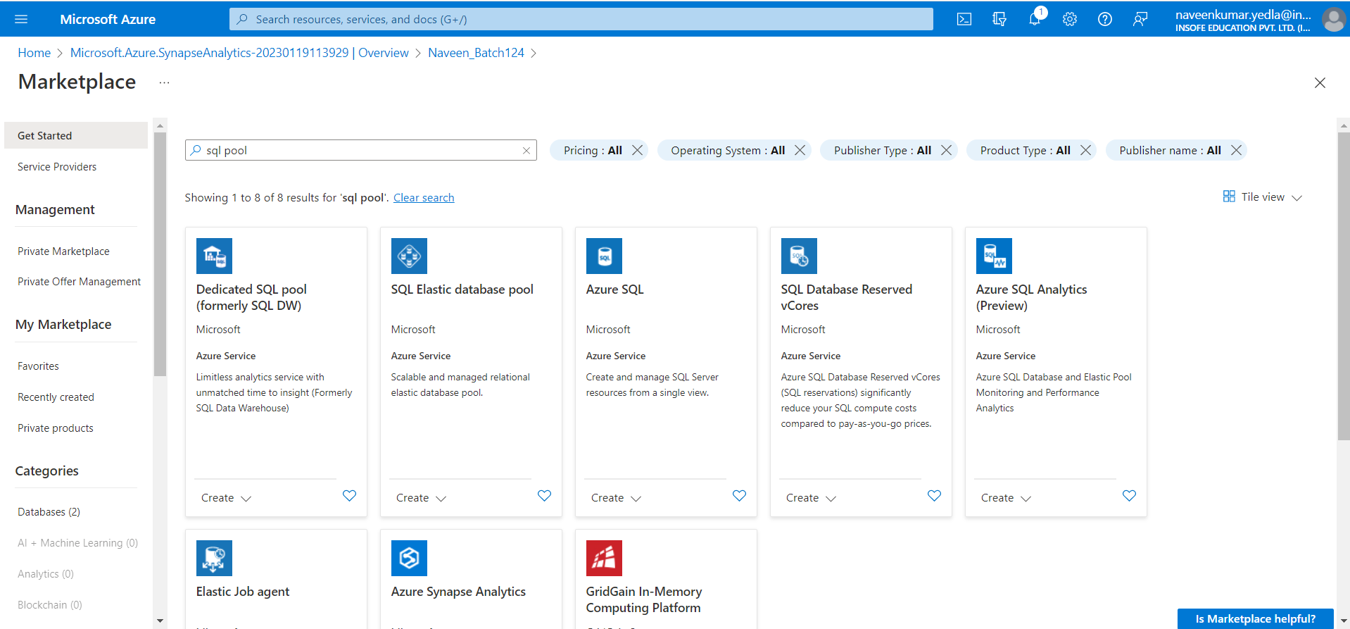

1. In Basic tab enter the following details
2. Subscription: Pay- As-You-Go
3. Resource group: Select resource group if exists otherwise create a new one.
4. In SQL poo details enter the following
5. SQL pool name: Enter unique name.
6. Server: Click on new and create a new sever

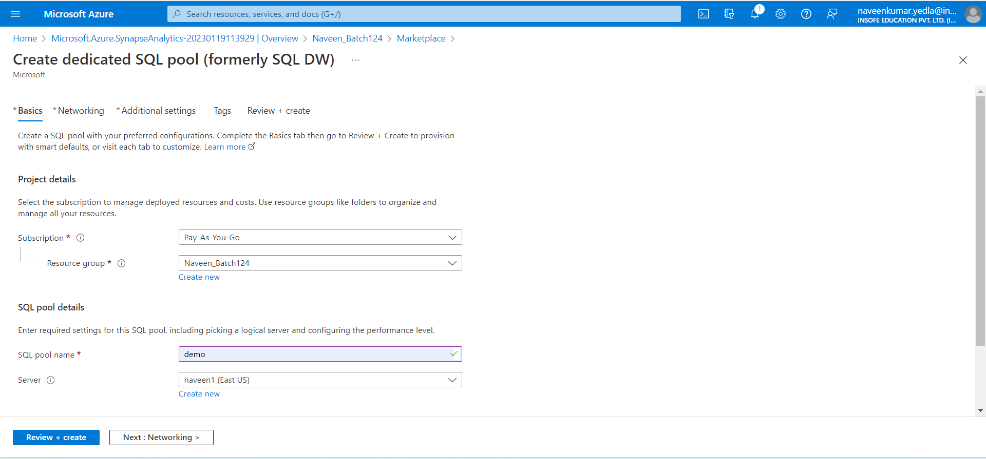

1. Server name: Enter server name
2. Location: East US
3. Under Authentication select set azure Ad admin. Azure active directory will open select your id and click on select
4. Click ok.

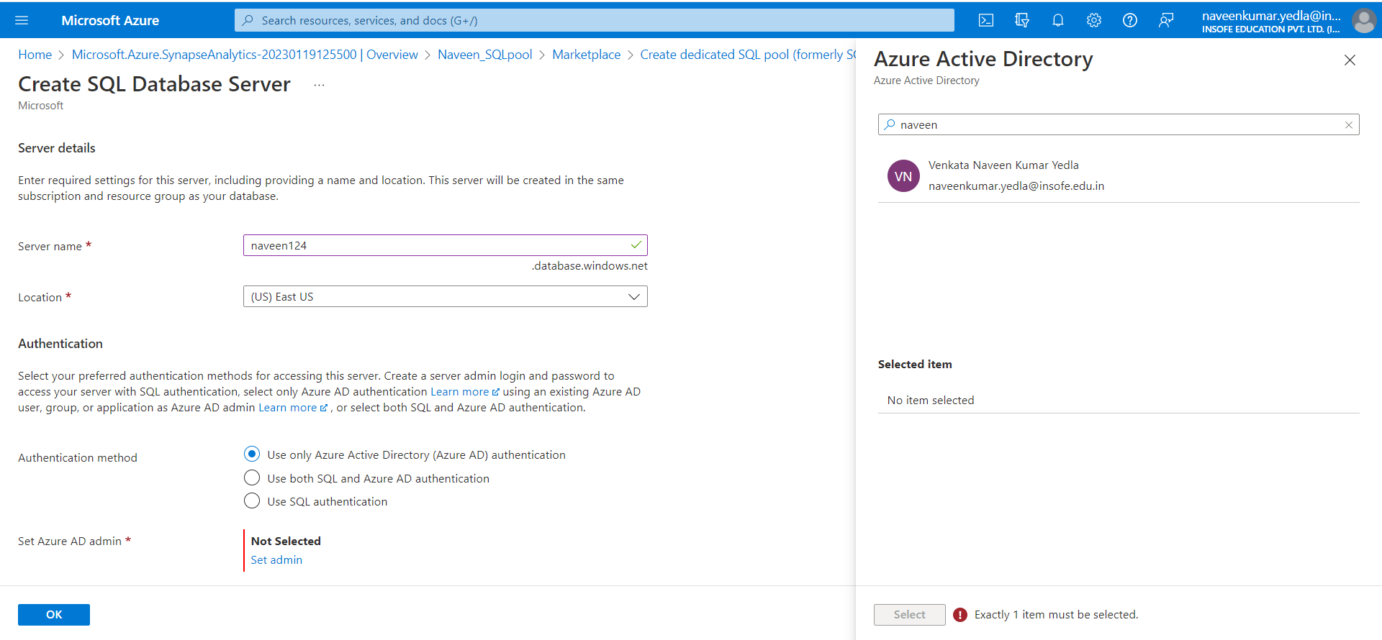

1. In Additional settings section under Data source
2. Use existing data: Select Sample

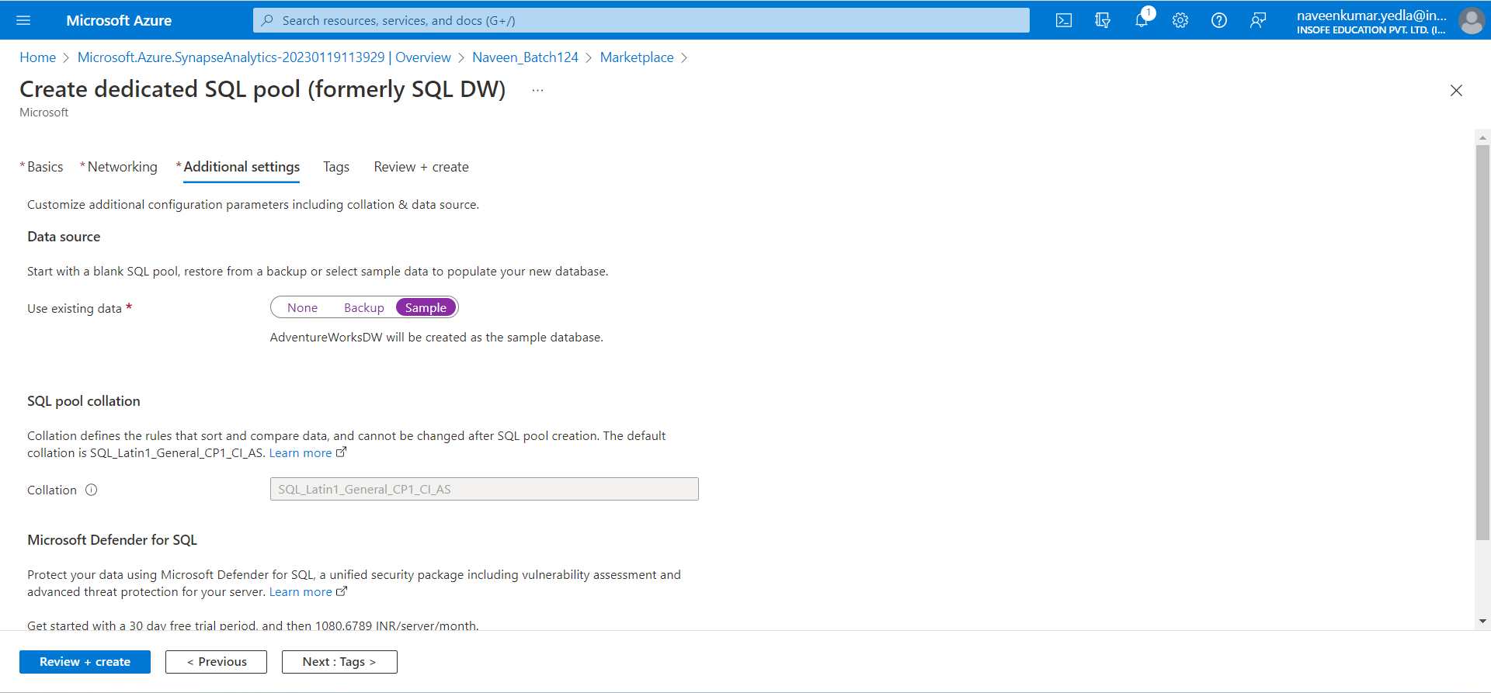

1. Leave remaining as default click review + create.
2. Click on create.

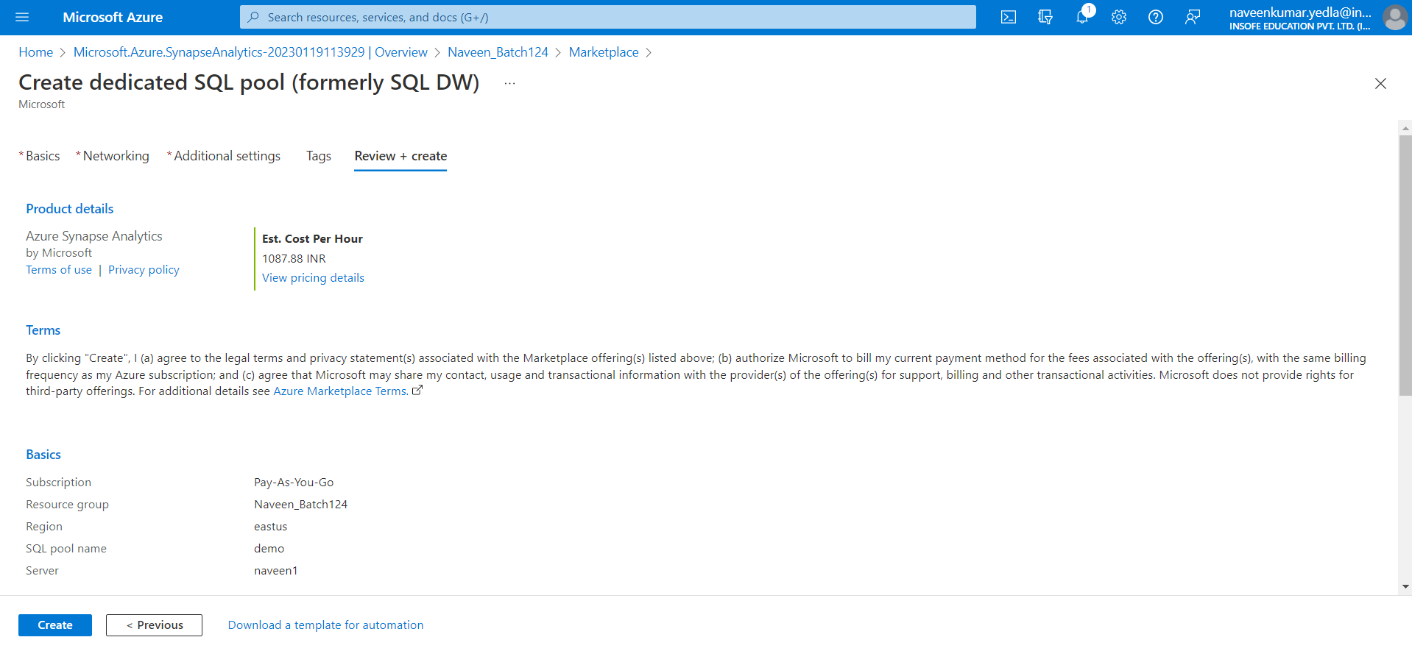

1. After deployment is complete click on Go to resource.

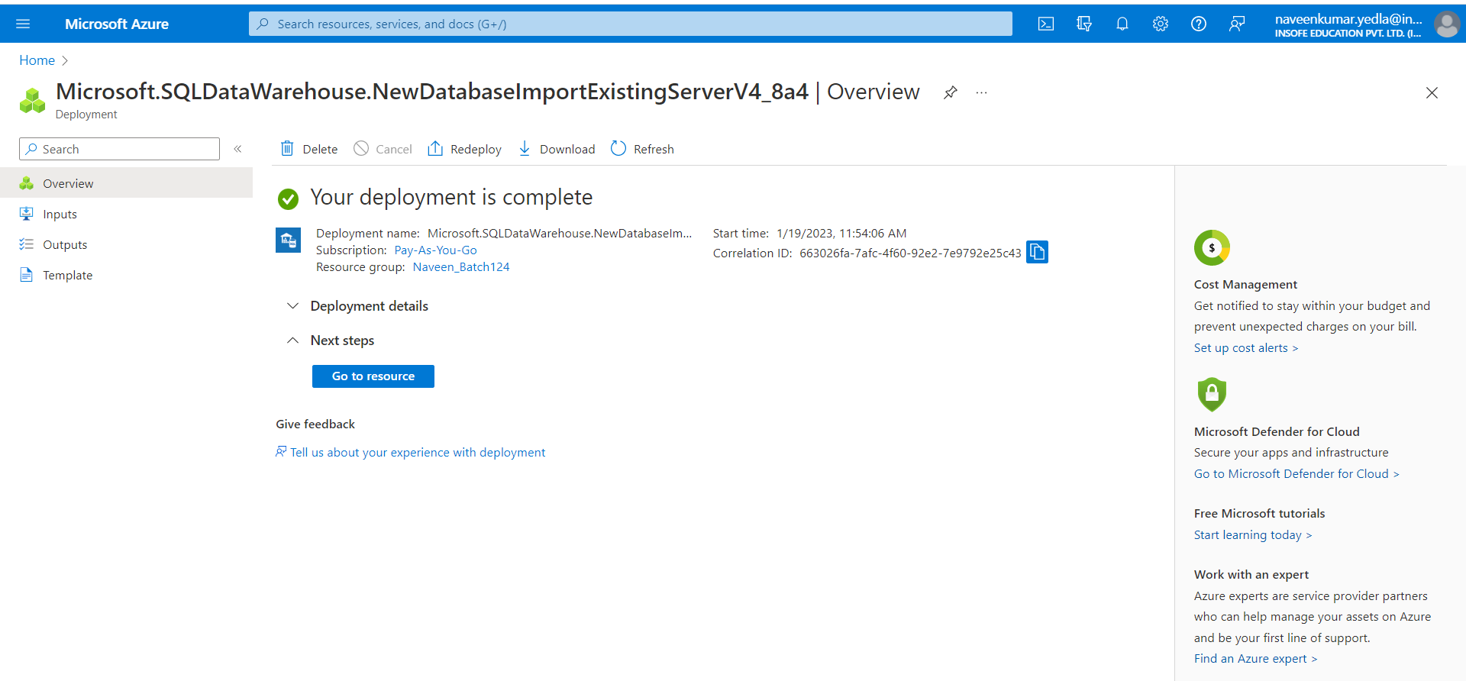

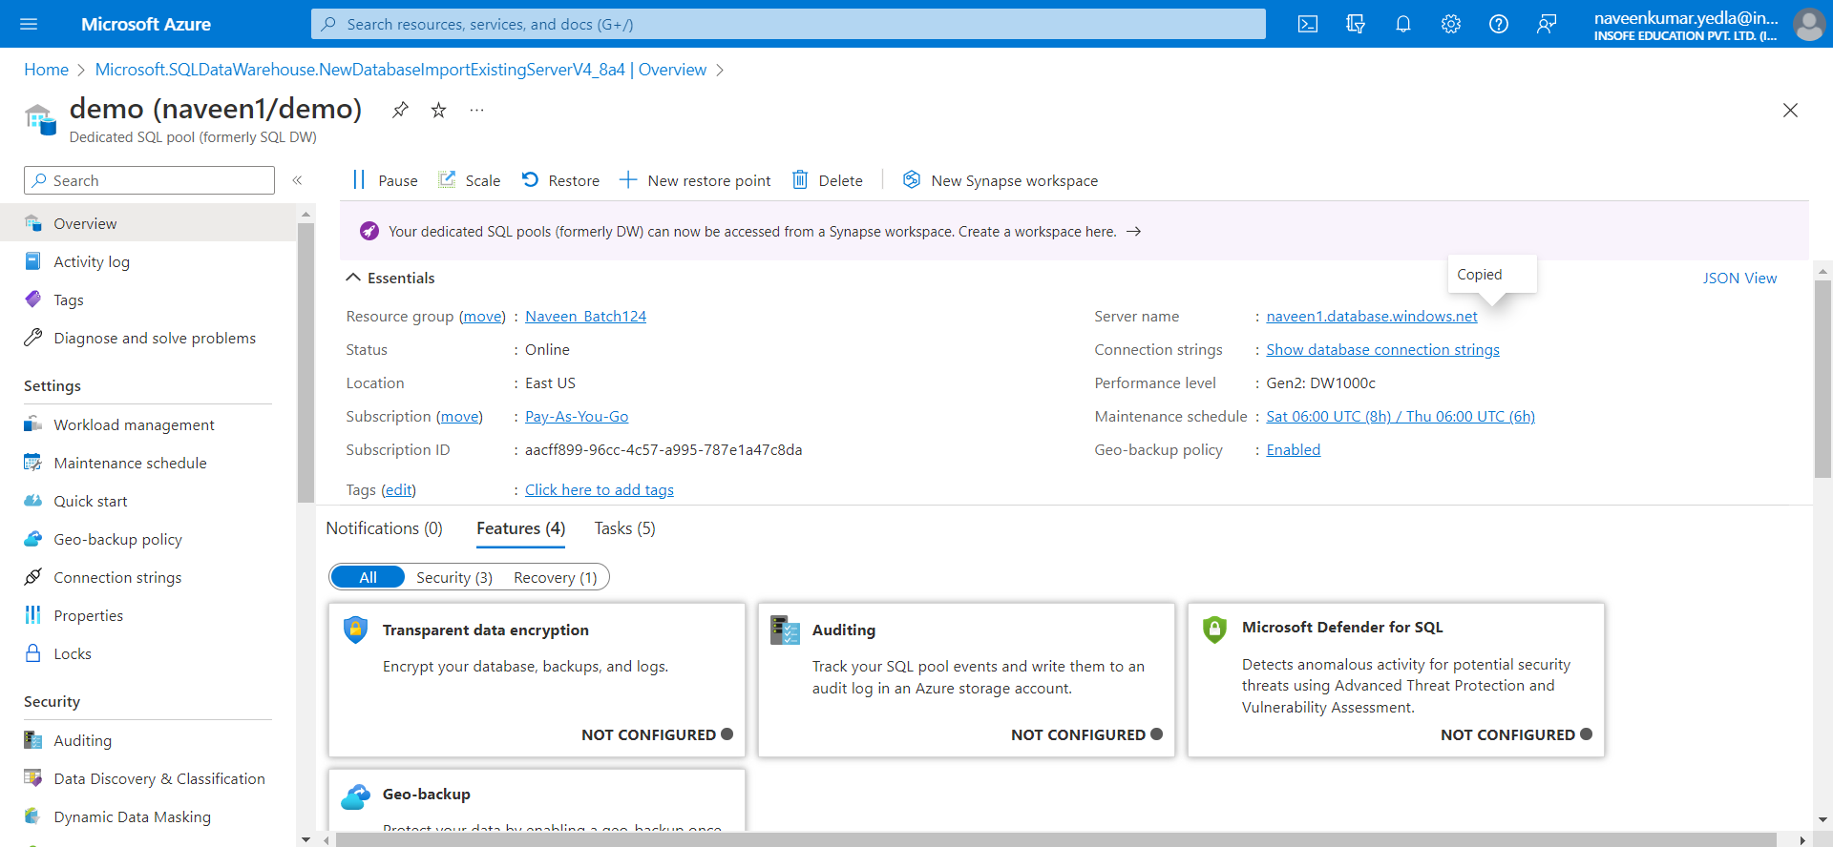

1. Select Query editor (preview)
2. Click on Allowlist IP 125.99.159.85 on server naveen1
3. Click on continue as (your id which you have created on step no 27)

